
College Arms

721, 731 and 733 S. High St
Built: 1920/30/70 | Size: 25.100 sf
Acquired: N/A | Condition: Average
Last Renovation: 2011 | Function: AUX

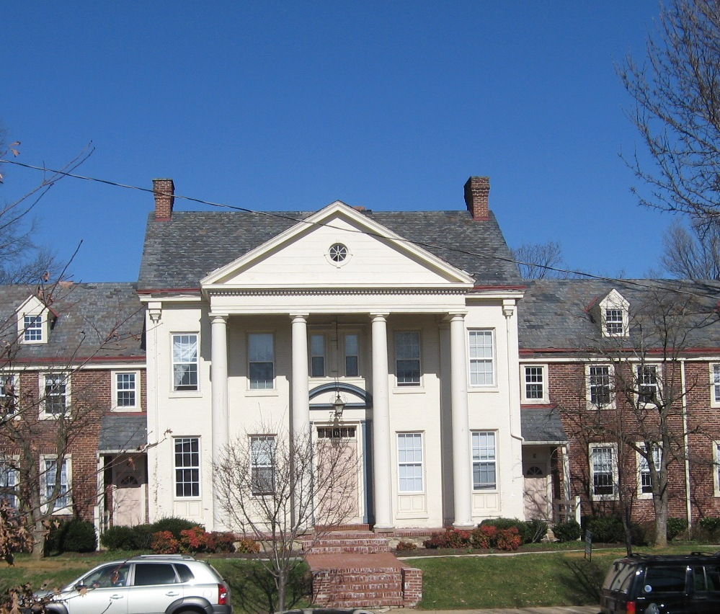

A renovation for code compliance and sprinkler/fire alarm coverage occurred in 2011, following a purchase in 2010, in anticipation of occupancy for Fall 2011, however, long term renovations have been deferred pending a life-cycle plan for the 3 separate structures.
The site consists of three separate buildings- the north building constructed in a neo-Georgian style that houses 25 apartments, the west stone building constructed in a colonial revival style that houses 6 apartments, and the more modern eastern brick building that houses 10 apartments.

Present Use: Residence Hall.

Disability Access: Partial accessibility on grade level apartments only. Accessible parking on site.

Past Projects: 2011 renovation for occupancy, including sprinkler and fire alarm upgrades, new carpet and paint, LAN and electrical and code upgrades. 2013 kitchen and bathroom upgrades, new sidewalks in north building, landscaping upgrades at south building.

Scheduled Projects or Capital Renovations: None

Description of Construction: Reinforced concrete and stone foundations, asphalt shingle and slate roofs, masonry brick veneer and stone exterior walls, wood framed floors.

Condition and Use Assessment:
Deferred Maintenance (2010): | Est Replacement Cost (2010):
Facility Condition Index: | Deficiency/SF:
Yearly Electric Use Cost: $ | Yearly Water Use Cost $

